Peaceful Playgrounds Programs Guide
2013 PEP Priorities and Requirements

The Peaceful Playgrounds Programs include:
- Peaceful Playgrounds Recess Program,
- Fundamental Movement Physical Education Program,
- Fitness Fun Zone,
- We Count Student Walking Program, and
- 2 Go Physical Activity Learning Materials

All programs were designed for Physical Education and Physical Activity experiences containing content and activities to increase student health outcomes in order to help a district align to their K-12 Physical Education District, State and National Standards.
Peaceful Playgrounds Programs Alignment With National (NASPE, National Association of Sport and Physical Education) and State Standards.
I. Absolute Priority: Programs Designed to Create Quality Physical Education Programs

(1) Instruction in healthy eating habits and good nutrition
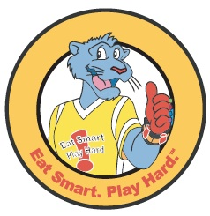
Eat Smart, Play Hard Curriculum and Program has been used as the nutrition partner for Peaceful Playground PEP Grants for the past 12 years. Eat Smart Play Hard is a federal nutrition program which emphasizes Healthy Lifestyles. The program was developed by the United States Department of Agriculture Food Services Division. The Eat Smart Play Hard curriculum utilizes evidence-based content and instructional strategies that are aligned with the recommendations of CDC and USDA to provide effective nutrition education materials and services to schools and staff. These materials were specifically designed for parents and district food service workers to provide information to help adults and children eat better and be more physically active. The ESPH website has downloadable materials and grade level kits.

(2) Physical fitness activities must include at least one of the following:
(a) Fitness education and assessment to help students understand, improve, or maintain their physical well-being.
The Fitness Fun Zone (FFZ), Peaceful Playgrounds (PP), We Count Walking Program (WCWP), and Fundamental Movement Physical Education Program (FMPE) were designed for physical education, classroom teachers teaching PE, and recreation centers, so that students have environmental opportunities to increase and improve their fitness by:

- Increasing Activity levels through multiple FUN fitness opportunities (FFZ)(PP) (WCWP)
- Improving Physical fitness through daily fitness activities (FFZ) (WCWP)
- Sport skills (PP) (FMPE)
- Enjoyment (PP) (FFZ) (WCWP) (PP 2-Go Games) (FMPE)
- Academic achievement (PP) (PP 2-Go Games) (FMPE)
- Activity levels away from school (WEWP) (PP) (FMPE)
- Sustainability (PP) (FFZ) & (FMPE) all rely on permanent painted activity markings.
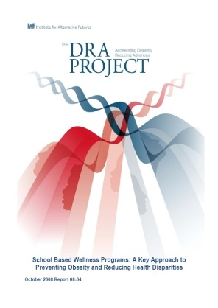

Peaceful Playgrounds was identified as a successful model for combating childhood obesity in the report, “School Based Wellness Programs: A Key Approach to Prevention Obesity and Reducing Health Disparities. (Peaceful Playgrounds, page 56, October 2008).
(b) Instruction in a variety of motor skills and physical activities designed to enhance the physical, mental, and social or emotional development of every student.
With the Fundamental Movement physical education program there was a forty-four percent (44.3%) increase in the number of students scoring above 40 on the Clark Motor Skills Inventory (58.7% and 84.7% at weeks 1 to 16). This data was collected and reported in the Saugus Unified SC PEP Grant Evaluation in 2008.

In the same evaluation, the average number of steps taken by students between October 2004 and May 2005 increased by 7,638 (48.6%) as measured by pedometers.

In another PEP Evaluation in a consortium grant in Southern California, there was a sharp decrease (8 percentage points) in self-reported bullying among fifth graders (42% to 34%, respectively) as measured by the California Youth Risk Behavior Survey. This indicates, as did student surveys, that students felt emotionally and physically safe in an improving environment.

(c) Development of and instruction in cognitive concepts about motor skills and physical fitness that support a lifelong healthy lifestyle.
Fundamental Movement PE Program has an indoor classroom cognitive element of the program called 2-Go Games where students use companion game cards with integrated academic activities that tie into Language Arts and Math Standards.
The Fitness Fun Zone was developed to enhance students’ fitness development and is a permanent environmental change, resulting in increased physical education and physical activity opportunities. With daily fitness games and activities, the FFZ ensures that students increase physical activity during class time, and the court is available for recess and afterschool programs.
(d) Opportunities to develop positive social and cooperative skills through physical activity participation.
The social skills component is thought to be one of the strongest components of the Peaceful Playgrounds program which includes conflict resolution strategies, and problem solving solutions resulting in a decrease in playground conflicts, arguments and referrals.
Additionally, Peaceful Playgrounds was recognized by Palestra Magazine, a resource specializing in sport, physical education, and recreation for individuals with disabilities, their parents, and professionals. The Spring 2002 article and cover story was on the Peaceful Playgrounds Program, and recommended it to their readers. “Since there is no lift or elevation in these areas, access is easy, and all surfaces comply with the Americans with Disabilities Act guidelines” (U.S. Department of Justice, 1990).

(e) Opportunities for professional development for teachers of physical education to stay abreast of the latest research, issues, and trends in the field of physical education.
Peaceful Playgrounds has numerous methods of offering Professional Development to teachers and staff:
- On-site professional development,
- Professional Development training materials (PowerPoint, handouts & Facilitator Notes) are included in every Peaceful Playgrounds product),
- Bi-monthly live webinars, on-demand webinars, and online line training courses ensure that all teachers have the latest research based information available to them anytime and anywhere.

The Peaceful Playgrounds Programs Newsletter is also available two times a month, and the program also offers a professional development library of podcasts, videos, reports, and tool kits on current topics in physical education, fitness, childhood obesity, physical activity, nutrition, and bullying prevention.

II. Competitive Preference Priority 1: Turning Around Persistently Lowest-Achieving Schools
Under this priority, we give competitive preference to projects that are designed to address the following priority area:

Providing services to students enrolled in persistently lowest-achieving schools. A list of these Tier I and Tier II schools can be found on the Department's Web site at http://www2.ed.gov/programs/sif/index.html.

III. Competitive Preference Priority 2: Partnerships between Applicants and Supporting Community Entities
Competitive preference priority will be given to an applicant that includes in its application an agreement that details the participation of required partners, as defined in this notice. The agreement must include a description of:

(1) each partner’s roles and responsibilities in the project;
(2) how each partner will contribute to the project, including any contribution to the local match;
(3) an assurance that the application was developed after timely and meaningful consultation between the required parties, as defined in this notice; and
(4) a commitment to work together to reach the desired goals and outcomes of the project. The partner agreement must be signed by the Authorized Representative of each of the required partners and by other partners as appropriate.

IV. Invitational Priority 1: Design Filters for Physical Activity Programs
Background
In September 2012, as part of its Let’s Move! initiative, the White House promoted the use of seven “design filters” to serve as guidelines for both public and private sectors in creating physical activity programs. These are evidence-based program practices developed by experts from the public, private, and philanthropic sectors.
We believe that the seven design filters complement the priorities and requirements in this notice. Additional information about the seven design filters is available at:
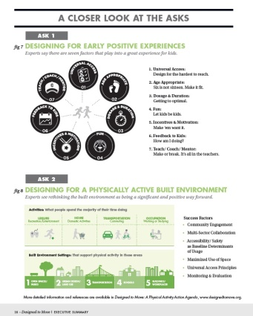
http://ahealthieramerica.org/sites/all/themes/pha/files/PHA_Policy_Brief_and_Design_Filters.pdf

This priority is projects that propose to align their programs with the following design filters. Programs should:
1. Strive for universal access. Peaceful Playgrounds games and markings are all at ground level and therefore meet Federal ADA requirements.
2. Include a range of age appropriate activities.
Peaceful Playgrounds Physical Activity/Recess Program has 4 grade level spans: PreK, Kdg, Grades 1-3, Grades 3-6. Blueprints and activity guides ensure that activities are developmentally appropriate.
3. Aim to reach the recommended guidelines on dosage and duration.
The Peaceful Playgrounds Program offers a unique experience designed to assist students in reaching the goal of 60 minutes of PA each day. In addition to recess, lunch, and afterschool physical activity minutes, there are also follow up recommended PA Activities for home.

4. Be engaging and fun for kids;
In student surveys, students often list “recess” at Peaceful Playground schools as their favorite activity/class at school
5. Be led by well-trained coaches and mentors.
Ideally, physical education specialists present the Fundamental Movement Curriculum. However, coaches, classroom teachers, and paraprofessionals have successfully implemented Peaceful Playgrounds Recess, We Count Walking Program, and Fitness Fun Zone successfully, resulting in gains. Physical activity increases, bullying decreases, motor skill development increases, and conflicts on the playgrounds decrease.
6. Track progress, both individually and for the group.
The WE Count Walking program has numerous tools for tracking physical activity includingstep charts, certificates, pedometers, goal setting tools, monitoring devices like benchmark cards and motivational stickers.

7. Provide consistent motivation and incentives.
Link to a copy of the Framework for Action: Design Filters to download. As discussed above, there are numerous motivational tools and incentives in each program: namely certificates, coupons, checklists, tracking tools, etc.

V. Invitational Priority 2: Turning Around Priority Schools

This priority is: Projects that provide services to students enrolled in priority schools (as defined in this notice).
Requirements: The following requirements, which are from the notice of final priorities, requirements, and definitions published in the Federal Register on June 18, 2010 (75 FR 34892), apply to this competition:
- Requirement 1—-Align Project Goals with Identified Needs Using the School Health Index (SHI)
- Requirement 2--Nutrition- and Physical Activity-Related Policies
- Requirement 3--Linkage with Local Wellness Policies
- Requirement 4--Linkages with Federal, State, and Local Initiatives
- Requirement 5--Updates to Physical Education and Nutrition Instruction Curricula
- Requirement 6--Equipment Purchases
- Requirement 7--Increasing Transparency and Accountability
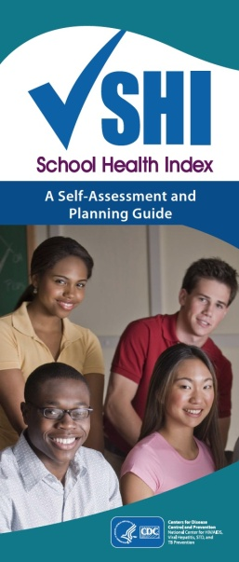

Requirement 1—Align Project Goals with Identified Needs Using the School Health Index

Aligning Project Goals with Identified Needs Using the School Health Index
Applicants are required to complete the physical activity and nutrition questions in Modules 1-4 of the CDC’s School Health Index (SHI) self-assessment tool or use an alternative needs assessment tool to develop project goals and plans that address the identified needs.
Requirement 1: School Health and Safety Policies and Environment
Requirement 2: Health Education
Requirement 3: Physical Education and Other Physical Activity Programs
Requirement 4: Nutrition Services
Requirement 5: Updates to Physical Education and Nutrition Instruction Curricula
Requirement 6: Equipment Purchases
Requirement 7: Increasing Transparency and Accountability

Requirement 2---Nutrition and Physical Activity-Related Policies

Grantees must develop, update, or enhance physical activity policies and food and nutrition-related policies that promote healthy eating and physical activity throughout students’ everyday lives, as part of their PEP projects.
These materials are available in the Eat Smart Play Hard program materials and are free to order.
Requirement 3---Linkage with Local Wellness Policies

Applicants that are participating in a program authorized by the Richard B. Russell National School Lunch Act and the Child Nutrition and WIC Reauthorization Act of 2004 must describe in their applications their school district’s established local wellness policy and how the proposed PEP project will align with, support, complement, and enhance the implementation of the applicant’s local wellness policy. The LEA’s local wellness policy should address all requirements in the Child Nutrition Act of 1966.
Requirement 4---Linkages with Federal, State, and Local Initiatives

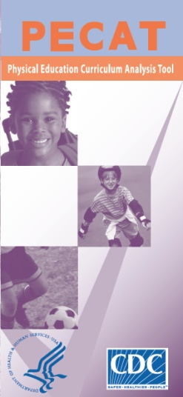
If an applicant is implementing the CDC’s Coordinated School Health program, it must coordinate project activities with that initiative and describe in its application how the proposed PEP project would be coordinated and integrated with the program.
If an applicant receives funding under the USDA’s Team Nutrition initiative (Team Nutrition Training Grants), the applicant must describe in its application how the proposed PEP project supports the efforts of this initiative.
A PEP Project in a community that receives a grant under the Recovery Act Communities Putting Prevention to Work (CPPW)-Community Initiative must agree to coordinate its PEP project efforts with those under the Recovery Act CPPW-Community Initiative.

Requirement 5---Updates to Physical Education and Nutrition Instruction Curricula

Applicants that plan to use grant-related funds, including Federal and non-Federal matching funds, to create, update, or enhance their physical education or nutrition education curricula are required to use the Physical Education Curriculum Analysis Tool (PECAT) and submit their overall PECAT scorecard, and the curriculum improvement plan from PECAT. Also, those applicants that plan to use grant-related funds, including Federal and non-Federal matching funds to create, update, or enhance their nutrition instruction in health education must complete the healthy eating module of the Health Education Curriculum Analysis Tool (HECAT). Applicants must use the curriculum improvement plan from the HECAT to identify curricular changes to be addressed during the funding period. Applicants must also describe how the HECAT assessment would be used to guide nutrition instruction curricular changes. If an applicant is not proposing to use grant-related funds for physical education or nutrition instruction curricula, it would not need to use these tools.
  - To enhance their physical education or nutrition education curricula are required to use the Physical Education Curriculum Analysis Tool (PECAT) and submit their overall PECAT scorecard, and the curriculum. (See Peaceful Playgrounds Programs PECAT Evaluation and Scorecard).

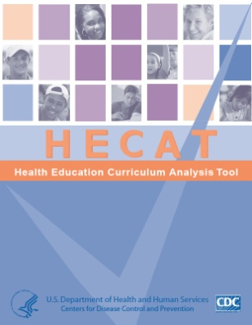
  - Also those applicants that plan to use grant-related funds, including Federal and non-Federal matching funds to create, update, or enhance their nutrition instruction in health education must complete the healthy eating module of the Health Education. Curriculum Analysis Tool (HECAT). Applicants must use the curriculum improvement plan from the HECAT to identify curricular changes to be addressed during the funding period. Applicants must also describe how the HECAT assessment would be used to guide nutrition instruction curricular changes and align with the improvement plan from PECAT.

Peaceful Playgrounds has completed the PECAT Evaluation and Scorecard on our curricula for you. Link to PPP PECAT Evaluation and SCORECARD.
Requirement 6---Equipment Purchases
Purchases of equipment with PEP funds or with funds used to meet the program’s matching requirement must be aligned with the curricular components of the proposed physical education and nutrition program. Applicants must commit to aligning the students’ use of the equipment with PEP elements applicable to their projects, identified in the absolute priority in this notice, and any applicable curricula, by signing a Program-Specific Assurance. Applicants that do not submit a Program-Specific Assurance signed by the applicant’s Authorized Representative are ineligible for the competition.
Each Peaceful Playgrounds Program comes with a companion equipment package. This is equipment includes the necessary materials so that students have adequate practice opportunities and the instructional tools and equipment needed to properly implement each program.
Download our PEP Budget with Equipment, Curriculum, and training packages for each program.

Requirement 7---Increasing Transparency and Accountability

Grantees must create or use existing reporting mechanisms to provide information on students’ progress, in the aggregate, on the key program indicators, as described in this notice and required under the Government Performance and Results Act, as well as on any unique project-level measures proposed in the application. Grantees that are educational agencies or institutions are subject to applicable Federal, State, and local privacy provisions, including the Family Educational Rights and Privacy Act-- a law that generally prohibits the non-consensual disclosure of personally identifiable information in a student’s education record. All grantees must comply with applicable Federal, State, and local privacy provisions. The aggregate-level information should be easily accessible by the public, such as posted on the grantee’s or a partner’s Web site. Applicants must describe in their application the planned method for reporting.
Applicants must commit to reporting information to the public by signing a Program-Specific Assurance. Applicants that do not submit a Program-Specific Assurance signed by the applicant’s Authorized Representative are ineligible for the competition.
Assistance with tracking and reporting requirements is available through Peaceful Playgrounds.
Performance Measures
Grantees must collect and report data on three GPRA measures using uniform data collection methods. Measure one assesses student physical activity levels, The percentage of students served by the grant who engage in 60 minutes of daily physical activity. Grantees are required to use pedometers for students in grades K-12 and an additional 3-Day Physical Activity Recall (3DPAR) instrument to collect data on students in grades 5-12.
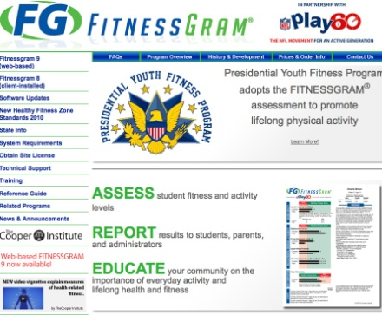
(See GRPA Performance Measures below).
The Secretary has established the following key performance measures for collecting data to use in assessing the effectiveness of PEP:

- The percentage of students served by the grant who engage in 60 minutes of daily physical activity measured by using pedometers for students in grades K-12 and an additional 3-Day Physical Activity Recall (3DPAR) instrument to collect data on students in grades 5-12.

- The percentage of students served by the grant who meet the standard of a healthy fitness zone as established by the assessment for the Presidential Youth Fitness Program (PYFP) in at least five of the six fitness areas of that assessment.
- The percentage of students served by the grant who consume fruit two or more times per day and vegetables three or more times per day as measured in programs serving high school students using the nutrition-related questions from the Youth Risk Behavior Survey and in programs serving elementary and middle school students using an appropriate assessment tool for their populations.

For your convenience we have included links to the requirement measures.

Important links to additional PEP resources

School Based Wellness Programs: A Key Approach to Preventing Obesity and Reducing Health Disparities October 2008 Report 08-04.

EAT SMART. PLAY HARD.™ - Team Nutrition
teamnutrition.usda.gov/Resources/EatSmart/guidelines.pdf

Share
File Format: PDF/Adobe Acrobat - Quick View
Local FNS Program Operators and. Affiliated Organizations, and Partners.

USDA/FNS owns the trademark and copyright to EAT SMART. PLAY HARD.

